A Comparative Study of Ray Tracing and Rasterisation

Kieran Warren
Department of Computing and Maths
University of Derby
Derby, United Kingdom

Abstract—An in depth study into Rasterization and Ray Tracing with detailed comparison on when each should be used and how they can be used effectively.
Keywords—Graphics; Rasterization; Ray Tracing;

Introduction
Throughout this paper I will be presenting research from reputable sources on the use of rasterization and ray tracing in computer graphics and what benefits and features each can provide to a graphics application. I will be comparing them to give a clearer understanding on when it is appropriate to use each methods and discuss my experiences with the use of ray tracing and how the use of it helped to improve the result of my work.

Explanation

Ray Tracing
Ray tracing, otherwise known as ray casting is a popular technique for image synthesis: creating a 2D image of a 3D world [1]. It has a number of uses not just for producing graphical effects such as lighting maps. Other applications can include visibility detection, collision detection and more [2]. However in computer graphics, ray tracing is used to produce a correct colour for each pixel on the screen. This isn’t particularly hard to define, in the real world a photon would deflect from the surface and the light particles/photons that reach the eye produce the images we see based on the energy of the photon [3].
While it is a relatively simple concept, the big issue is calculating the intersection point of a ray with an object in a 3D world. A ray is typically defined using the equation
P(t) = S + tV. 
where S represents the starting position of the ray, and V represents the direction of the ray [4]. However to calculate the ray intersection with a surface we need to substitute this equation into other equations depending on the kind of surface. Objects are most commonly created as triangles in the object space. One of the most common and efficient algorithms to

Fig. 1. Diffuse reflection from a Lambertian surface [5].
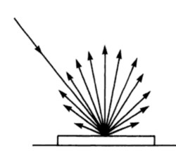

calculate the point of intersection is the Möller–Trumbore algorithm. It provides a relatively simple and very effective method of calculating intersections. The algorithm is efficient as it does not need to be computed on the fly or stored which can lead to a reduction in memory usage [6].
The data provided by ray tracing can be expanded upon to reproduce real world effects at a high quality with high- efficiency. The most common effects based on ray tracing reproduced in games and 3D scenes are reflection, refraction and shadows.
Reflection can be divided into three kinds of reflection. Diffuse, specular and image reflection. Diffuse and specular reflection are generally combined together and appears on surfaces that do not use a reflective material.
The diffuse reflection also known as Lambertian reflection results in the surface’s diffuse colour of the surface being reflected uniformly in all directions [7]. It is used on rough surfaces and an example of this reflection can be seen in Figure 1 and helps demonstrate that the appearance of the Lambertian reflection does not depend on the camera position [7].
Specular reflection is often combined with diffuse reflection and gives a less uniform reflection of the light on the surface and gives the appearance of a shinier surface. The specular reflection tends to reflect the light strongly in the path specified by the reflection of the light direction at the surface normal at the point of intersection [7]. The Phong model is one of the most widely used and provides a reflection of the light at the exact reflection at the surface normal on the intersection.
Fig. 2. (a) Reflected ray. (b) Refracted Ray. [8]
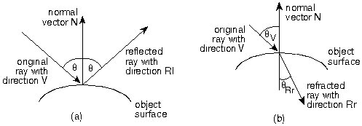

The Blinn-Phong model expands on the original Phong model and includes the Half-Vector to give a smoother specular reflection on the surface. The Blinn-Phong model requires the
most computational power to be processed with shading being calculated per pixel on the face of a triangle [9]. Alternatively, the Gouraud methods offers a much faster method but compromises on visual fidelity. Instead of being calculated at each pixel, the Gouraud model calculates it at each vertex of the triangle [9].
For image reflection and refraction, a recursive ray tracing model is used. The first run of the recursive procedure finds the first object that intersects with the ray [10]. Then we find the normal of the intersection point and use this data to calculate either the reflection or refraction.
In image reflection, the reflected ray is created at the reflected angle in the normal of the intersection point as seen in figure 2a. We can retrieve the reflection direction and create a new ray from
R = 2N cos θ – L, 
where R is the reflected vector, N representing the normal and L representing the original vector direction [11].
Refraction is a little more complex and requires the refracted ray to be calculated at least twice before it can work. Refraction requires an internal ray inside the object and an exit ray at the intersection point of the internal ray. The direction vector of the refracted ray is given by
T = μ I – (cos θ + μ cos ϕ) N, 
where T is the resulting vector, I is the original vector, and N is the normal [11].
Being recursive functions, they can be repeated an infinite number of times. This can have a strong effect on performance and so we require a value for the depth of the trace to limit performance. For basic reflection we need a depth of at least two and to deal with any transparent objects using refraction we require a minimum depth of 3 [10].
Shadow mapping is the most popular method of creating shadows and is rendered from the perspective of the light source [12]. The Shadow Z-buffer is one of the simplest and most commonly used algorithms to compute shadows. A scene is rendered and depth information is stored using the light source as the view point [13]. The Z-buffer holding the data is then used when rendering from the camera. For each object being intersected by the ray, if the Z value of the object is greater than the value currently in the Z buffer then it is determined that another surface is closer to the light source [13]. With this data we can cast a shadow on that point of the surface.

Rasterisation
Rasterization is a fundamentally different method to ray tracing for producing an image of a 3D scene. Currently rasterization is the dominant approach for rendering a 3D scene thanks to its initially low computational requirements [14].
Divided into a number of stages, the first stage is face culling. Face culling is usually applied at the beginning of the pipeline and is an optimization used to remove faces of polygons that are facing away from the camera [15].
Once the optional face culling operation has been completed, rasterization is the process completed by the GPU to determine which pixels in the viewport are covered by each graphics primitive [15].
After that the fragment shading process is completed, used to determine the final colour and depth of each pixel. The result may be simply given by the colour of a texture or may include more complex calculations that include a per-pixel lighting calculation [15].
The final stage, the fragment operations which are performed on each of the fragments can be divided into a number of sub-operations depending on the complexity required by the application.
Pixel ownership test determines whether the fragment is visible by the camera. The fragment may be behind the camera so does not need to be rendered. The scissor test can be used to exclude a specific section of the viewport for rendering. This is an optimization useful for games that use a HUD. The game no longer needs to render underneath the HUD. If a fragment passes the scissor test, it can then move on to the alpha test to determine the alpha values/transparency in the pixel. If the pixel passes the alpha test it moves on to the stencil test. This test reads the value of the stencil buffer at the location of the fragment location and compares it to the value specified by the application. The fragment only passes this stage if it satisfies a particular relationship. The final test in the fragment operations is the depth test. It compares the depth value currently associated with the fragment with the value in the depth buffer. Normally the fragment depth needs to be less than or equal to the current value, this means that it is within a reasonable distance to the camera and the original value of the depth buffer can sometimes be referred to as the draw distance [15].
With these operations completed, the final phase is image blending. This phase combines the final colour of the fragment with the current colour of the buffer. This is where the alpha value is crucial as it determines how much the new fragment should be blended with the current value in the buffer [15].

Comparison
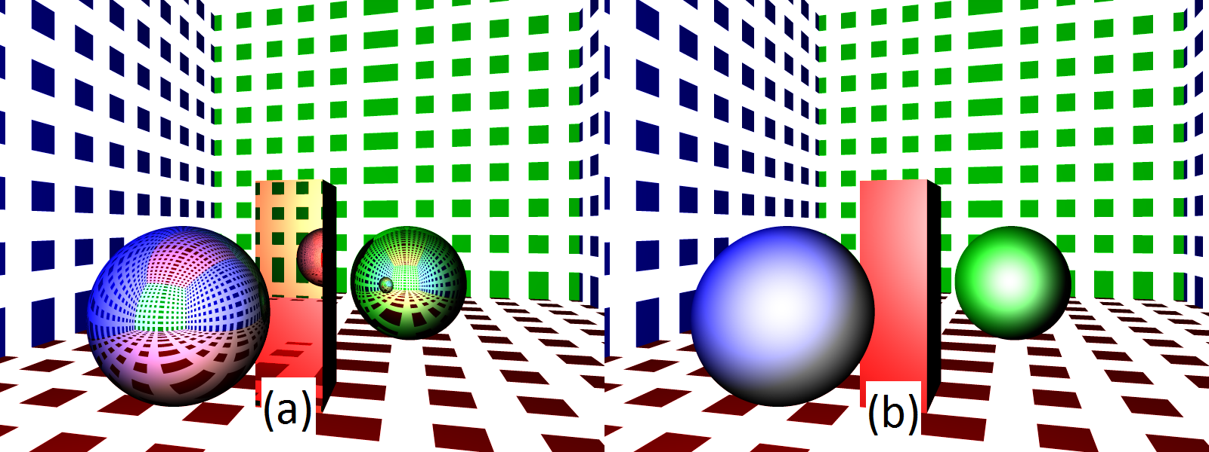
In applications, rasterization is still by far the most commonly used technique. It provides efficient performance and GPUs have hardware dedicated to speeding up the process. Ray tracing however offers the ability to create worlds with far higher graphical fidelity with realistic reflections and refractions. These features are much more difficult to reproduce when using rasterization and fake reflections are usually used in rasterization.
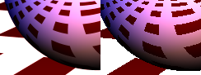
The issue with ray tracing is that current graphics hardware rarely has enough power to produce a ray traced scene on the fly. This means that it is far from ideal in games. However animation, which is done offline can use ray casting and deliver the higher graphical fidelity.
Pixar’s Cars was one of the first major animations to use ray tracing. Some scenes were far more complex than the animations usually released and the use of cars required high quality reflection that traditional rasterization could not offer. Pixar’s RenderMan renderer offers some interesting optimization to make it more capable of handling the most complex scenes. The REYES algorithm can distribute the rendering process across a number of cores as it renders only a small image tile of 16x16 or 32x32 at a time [16]. While the algorithm can produce extremely high quality visuals, the benchmarks on complex scenes completed by Pixar show that current hardware is far from capable of ray casting in real time. A single image from the Cars movie took 106 minutes to be completed on a PC with average hardware and caused a total of 1.2 billion ray-triangle intersection tests [17]. The complexity of the scene could be greatly reduced to reduce rendering time but would no longer offer the graphical benefits of ray tracing.

Methods

Introduction
My own work on ray tracing implemented a number of the features described earlier as well as some that were not featured above which I will go into some detail about. The work I was able to complete was aided by the framework and scene provided by Dr. Minsi Chen.

Intersection Tests
The minimum possible scene produced by ray casting requires intersection tests between the rays and objects in the scene. I provided separate solutions for calculating intersections for planes, triangles and spheres.
The plane was by far the simplest and the only test required was to check if the intersection point was within the area of the plane.
The triangle required a similar solution due to it also being a flat surface, however a triangle is made up of three vertices. So some additional calculations were required on top of the plane equation to get the plane of the triangle, to then test for intersections the same as the plane intersection test.
Fig. 3. (a) Mirror reflection. (b) Diffuse and Specular reflection.
Fig. 4. Left: Multi-Sampling, Right: No Multi-Sampling
Sphere intersection tests required a lot more work and calculations. The intersection was found using a quadratic equation. This meant that there can also be two intersection points. For each of the intersection points the position needed to be found and the distance from the camera. If there are two intersection points, they need to be compared to find which is closest. Only the closest should be rendered. Additionally, if there is only one solution to the quadratic equation then it is at the edge of the sphere and if there are no solutions to the equation then the ray does not intersect with the sphere.

Reflection
My solution to diffuse and specular were combined in the code and the result can be seen in figure 3(b). For diffuse reflection I used the most popular method that was described above. For specular reflection, I chose to go with the Blinn-Phong model as it provides a much more accurate specular reflection. The smoother specular reflection can be seen in figure 3(b), especially on the green circle with the bright light gradually fading as distance from the critical angle increases instead of a sharp drop off.
The mirror reflection that can be seen in in Fig. 3(a) is created with the use of (2). The result is impressive and objects accurately resemble mirrors. Upon closer inspection you can even see the recursive reflection continuing in the objects that appear in another objects reflection.

Anti-Aliasing/Multi-Sampling
One of the neat features of ray casting is that multiple rays can be sent per pixel. This feature can be crucial to providing smooth images similar to the left image in Fig. 4. The right image provides no blending of pixels on the edges creating a staircase effect. The multi-sampling that I successfully implemented allowed multiple rays to be fired for a subsection of a pixel essentially providing a higher resolution image and then blending the results for the final pixel colour.

Radial Attenuation
This was another graphical effect that I experimented with to some success. I achieved a gradient between light and dark in the image however the change between light and dark was a sharp change and not as smooth as it should have been.

Discussion
The biggest downfall of my work was not including refraction and shadows. After researching the techniques required for these effects more deeply since completing the work, the techniques are seem relatively simple and I don’t think they were particularly difficult or beyond my skill levels.
Instead of these features I chose to implement some other features. Anti-aliasing was by far my favourite feature that I was able to implement. The main issue with it however was the performance. The value I was using to adjust the amount of anti-aliasing resulted in an O(N2) effect on performance. With 4x anti-aliasing, 16 rays were being fired per pixel.
The minimum requirements for the project were done very well and I found no issues with my implementation of ambient, diffuse and specular reflection, using methods described above. The intersection algorithm stated above also worked flawlessly in my project.
My image reflection implementation also worked flawlessly and I was impressed by the result. The reflections were accurate and certainly made the objects appear as mirrors in the scene. This was probably the most complex of the advanced features that I was able to implement having to use some of the more complex equations required for ray tracing.
I had an issue with my implementation of radial attenuation. The issue, found after completion was the wrong value being used for radial attenuation causing the sharp drop off. I was not evaluating the correct value for its size causing a slightly sharp drop for the radial attenuation. Instead of using the length, I was using the dot product of the light direction and the surface normal. The sharper drop off result was interesting and the fact that it still provided some kind of radial attenuation with the dot product is very weird.

Conclusion
I don’t think it’s unreasonable to suggest that ray-tracing won’t really be seen in live demos or video games for a number of years. At least not any demos that would show the visual upgrades that ray tracing can bring over rasterization.
Even though current graphics hardware is incapable of producing a high quality ray traced scene it makes the future more exciting with ray tracing almost definitely replacing rasterization in the future and bringing a new level of immersion for video games.
That’s not to say that ray tracing can’t be used currently and I’ve previously stated an example of where it is already used and has been used for a number of years. A number of major animation producers are already using the ray-tracing technique including Pixar and many more including DreamWorks are developing their own ray tracing based solution. Animation is one of the only places that the technique can be used currently as it can be rendered offline and the animation can have access to ray-tracing optimized servers to produce it quicker. Even with the use of a server the rate of production would still not be fast enough to be produced live. There may be optimizations to the ray tracing algorithms that could improve the performance however large improvements in GPU performance will still be required before it can be used in game engines and in live demos.
In my opinion, the end result of my work was well put together, meeting the minimum requirements and going beyond adding features such as mirror reflection and anti-aliasing. I do regret not implementing refraction and shadows which would have resulted in a much better end product.

References
- A. S. Glassner, “An Overview of Ray Tracing,” in An Introduction to Ray Tracing, 1st ed., London, UK: Academic Press, 1989, pp. 1.
- E. Lengyel, “Ray Tracing,” in Mathematics for 3D Game Programming and Computer Graphics, 3rd ed., Boston, MA: Course Technology, 2012, pp. 131.
- A. S. Glassner, “Tracing Rays,” in An Introduction to Ray Tracing, 1st ed., London, UK: Academic Press, 1989, pp. 5.
- E. Lengyel, “Ray Tracing,” in Mathematics for 3D Game Programming and Computer Graphics, 3rd ed., Boston, MA: Course Technology, 2012, pp. 140-141.
- S. M. Judds, “Optical Fundamentals,” in Photoelectric Sensors and Controls, 1st ed., Everett, Washington: Marcel Dekker, Inc, 1988, pp 29.
- T. Moller and B. Trumbore, “Fast, Minimum Storage Ray/Triangle Intersection,” 1997, pp. 1.
- E. Lengyel, “Lighting and Shading,” in Mathematics for 3D Game Programming and Computer Graphics, 3rd ed., Boston, MA: Course Technology, 2012, pp. 161-162.
- P. Rademacher, "Ray tracing: Graphics for the masses," in The University of North Carolina. [Online]. Available: https://www.cs.unc.edu/~rademach/xroads-RT/RTarticle.html. Accessed: Feb. 26, 2016.
- E. Lengyel, “Lighting and Shading,” in Mathematics for 3D Game Programming and Computer Graphics, 3rd ed., Boston, MA: Course Technology, 2012, pp. 176-177.
- A. Watt, “Ray tracing strategies,” in 3D Computer Graphics, 3rd ed., Essex, UK: Addison-Wesley, 2000, pp. 349-350.
- A. Watt, “Mathematical fundamentals of computer graphics,” in 3D Computer Graphics, 3rd ed., Essex, UK: Addison-Wesley, 2000, pp. 24.
- E. Lengyel, “Shadows,” in Mathematics for 3D Game Programming and Computer Graphics, 3rd ed., Boston, MA: Course Technology, 2012, pp. 281.
- A. Watt, “Shadows,” in 3D Computer Graphics, 3rd ed., Essex, UK: Addison-Wesley, 2000, pp. 271-273.
- T. Davidovic et al., “3D Rasterization: A Bridge between Rasterization and Ray Casting,” 2012, pp. 1.
- E. Lengyel, “The Rendering Pipeline,” in Mathematics for 3D Game Programming and Computer Graphics, 3rd ed., Boston, MA: Course Technology, 2012, pp. 6-9.
- J. Fong et al., “Ray Tracing for the Movie ‘Cars’,” 2006, pp. 1.
- J. Fong et al., “Ray Tracing for the Movie ‘Cars’,” 2006, pp. 5.

